Warnings

The following procedure describes how to view all the warnings that currently exist in the store.

To view store warnings, go to **System → Warnings**. The *Warnings* window will be displayed as follows:

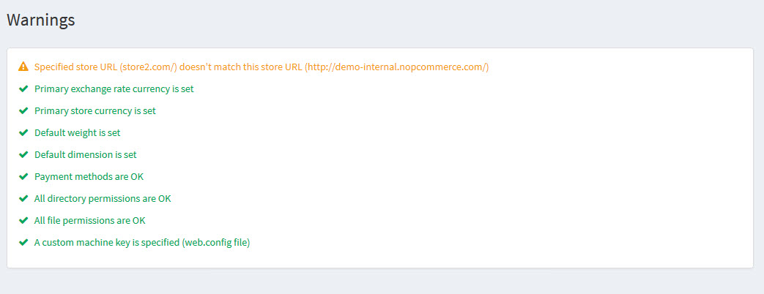

We recommend that you fix all the existing warnings. Otherwise, they will affect your store's efficiency and performance.